**Name: - k. pavan kumar**

**Student Id: - 11803055**

**Section: - K18JC**

**Roll No: - 41**

**E-mail id: - pavankumarkotaru2000@gmail.com**

**GitHub Link: - https://github.com/pavankumar2266/os-project/upload**

**Question Number 18.**

Ten students (a, b, c, d, e, f, g, h, i, j) are going to attend an event. There are lots of gift shops, they all are going to the gift shops and randomly picking the gifts. After picking the gifts they are randomly arriving in the billing counter. The accountant gives the preference to that student who has maximum number of gifts. Create a C or Java program to define order of billed students?

**Code: -**

#include<stdio.h>

#include<string.h>

#include<conio.h>

#include<stdlib.h>

void welcome()

{

printf("Name:pavankumar\n");

printf("Roll number: 41\n");

printf("Section:K18JC\n");

}

void Billing_counter() //calculate bill of student

{

char p[10][5], temp[5];

int i, j, pt[10], bt[10], tot=0, pr[10], temp1, n;

float avg;

printf("Enter no. of students present in gift shop:");

scanf("%d",&n);

for(i=0;i<n;i++)

{

printf("Enter student %d name:",i+1);

scanf("%s",&p[i]);

printf("Enter process time:");

scanf("%d",&pt[i]);

printf("Enter no of gifts:");

scanf("%d",&pr[i]);

printf("Enter burst time:");

scanf("%d",&bt[i]);

}

for(i=0;i<n-1;i++)

{

for(j=i+1;j<n;j++)

{

if(pr[i]>pr[j])

{

temp1=pr[i];

pr[i]=pr[j];

pr[j]=temp1;

temp1=pt[i];

pt[i]=pt[j];

pt[j]=temp1;

strcpy(temp,p[i]);

strcpy(p[i],p[j]);

strcpy(p[j],temp);

}

}

}

for(i=1;i<n;i++)sss

{

bt[i]=bt[i-1]+bt[i-1];

tot=tot+bt[i];

}

avg=(float)tot/n;

printf("G_name\t P_time\t No.Gifts B_time\n");

for(i=0;i<n;i++)

{

printf(" %s\t %d\t %d\t %d\n" ,p[i],pt[i],pr[i],bt[i]);

}

printf("Order of student in billing counter:\n");

for(i=0;i<n;i++)

{

printf("%s\t",p[i]);

}

printf("\navg waiting time=%f",avg);

getch();

}

int main()

{ welcome();

int a;

printf("Press 1 for main menu:\n");

printf("Press 2 for exit\n");

scanf("%d",&a);

switch(a)

{

case 1:

Billing_counter();

case 2:

exit(0);

}

return 0;

}

**Output**:

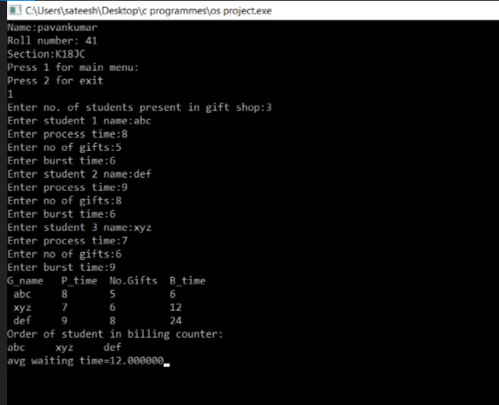

**1. Explain the problem in terms of operating system concept?**

**Description:**

Priority scheduling is a method of scheduling processes based on priority. In this method, the scheduler chooses the tasks to work as per the priority, which is different from other types of scheduling, for example, a simple round robin.

Priority scheduling involves priority assignment to every process, and processes with higher priorities are carried out first, whereas tasks with equal priorities are carried out on a first-come-first-served (FCFS).

**2. Write the algorithm for proposed solution of the assigned problem.**

**Algorithm**:

1- First input the processes with their burst time

and priority.

2- Sort the processes, burst time and priority

according to the priority.

3- Now simply apply FCFS algorithm

**3. Calculate complexity of implemented algorithm.**

**Complexity:**

Complexity of code is O((p+1)/2 * p +3p) ==> O(n*(n+1)/2) ==> O(n*n)

**4. Explain all the constraints given in the problem. Attach the code snippet of the implemented constraint.**

**Constraints:**

1) Value of number of gifts should be in integral and positive.

2) Value of arrival time should be positive and integral.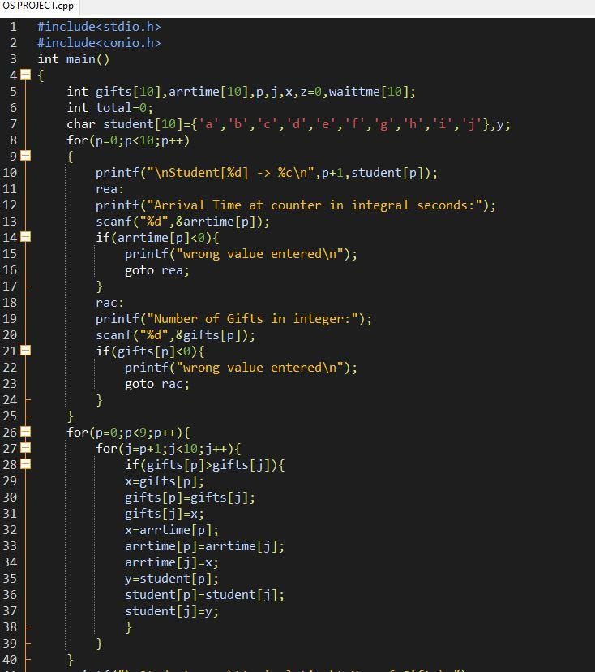

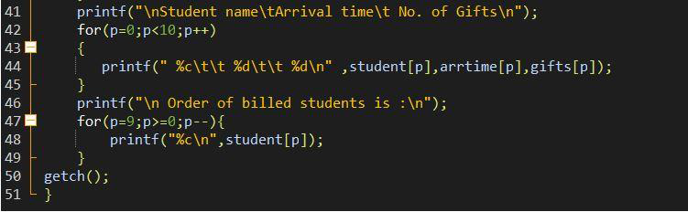

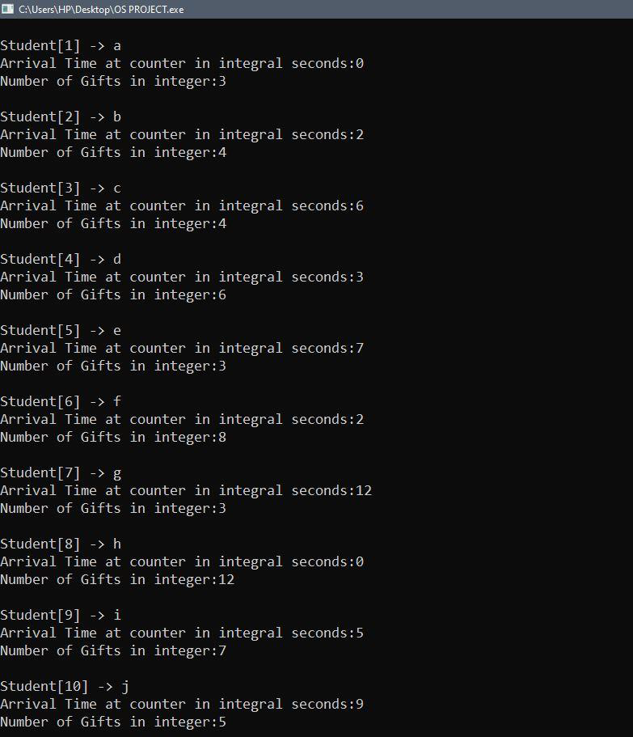

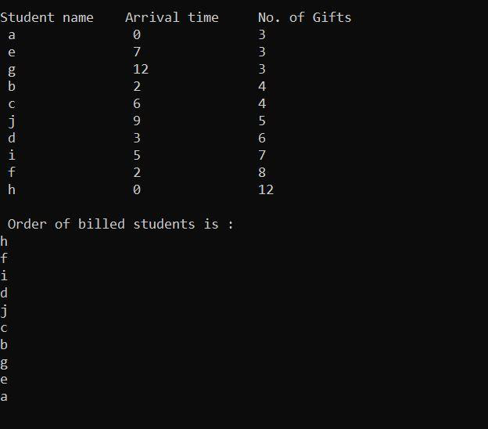

**5. If you have implemented any additional algorithm to support the solution, explain the need and usage of the same.**

**Description:**

No additional algorithm implemented.

**6. Explain the boundary conditions of the implemented code.**

**Description:**

In the code the values of arrival time and no. of gifts by which priority is being decided should be greater than zero and less than infinity.